Loading [MathJax]/jax/output/HTML-CSS/fonts/STIX/fontdata-1.0.js
Week 06: Graph Data Structures

Graph Definitions

Graphs | 2/67
Many applications require
- a collection of items (i.e. a set)
- relationships/connections between items
Examples:
- maps: items are cities, connections are roads
- web: items are pages, connections are hyperlinks
Collection types you're familiar with
- lists … linear sequence of items (week 3, COMP9021)
- trees … branched hierachy of items (COMP9021)
Graphs are more general … allow arbitrary connections

... Graphs | 3/67
A graph G = (V,E)
- V is a set of vertices
- E is a set of edges (subset of V×V)
Example:
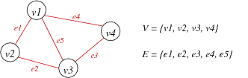

... Graphs | 4/67
A real example: Australian road distances
Distance | Adelaide | Brisbane | Canberra | Darwin | Melbourne | Perth | Sydney
Adelaide | - | 2055 | 1390 | 3051 | 732 | 2716 | 1605
Brisbane | 2055 | - | 1291 | 3429 | 1671 | 4771 | 982
Canberra | 1390 | 1291 | - | 4441 | 658 | 4106 | 309
Darwin | 3051 | 3429 | 4441 | - | 3783 | 4049 | 4411
Melbourne | 732 | 1671 | 658 | 3783 | - | 3448 | 873
Perth | 2716 | 4771 | 4106 | 4049 | 3448 | - | 3972
Sydney | 1605 | 982 | 309 | 4411 | 873 | 3972 | -
Notes: vertices are cities, edges are distance between cities, symmetric

... Graphs | 5/67
Alternative representation of above:
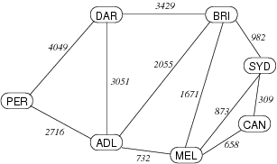

... Graphs | 6/67
Questions we might ask about a graph:
- is there a way to get from item A to item B?
- what is the best way to get from A to B?
- which items are connected?
Graph algorithms are generally more complex than tree/list ones:
- no implicit order of items
- graphs may contain cycles
- concrete erpresentation is less obvious
- algorithm complexity depends on connection complexity

Properties of Graphs | 7/67
Terminology: |V| and |E| (cardinality) normally written just as V and E.
A graph with V vertices has at most V(V-1)/2 edges.
The ratio E:V can vary considerably.
- if E is closer to V², the graph is dense
- if E is closer to V, the graph is sparse
  - Example: web pages and hyperlinks
Knowing whether a graph is sparse or dense is important
- may affect choice of data structures to represent graph
- may affect choice of algorithms to process graph

Exercise #1: Number of Edges | 8/67
The edges in a graph represent pairs of connected vertices. A graph with V has V² such pairs.
Consider V = {1,2,3,4,5} with all possible pairs:
E = { (1,1), (1,2), (1,3), (1,4), (1,5), (2,1), (2,2), …, (4,5), (5,5) }
Why do we say that the maximum #edges is V(V-1)/2?

… because
- (v,w) and (w,v) denote the same edge (in an undirected graph)
- we do not consider loops (v,v)

Graph Terminology | 10/67
For an edge e that connects vertices v and w
- v and w are adjacent (neighbours)
- e is incident on both v and w
Degree of a vertex v
- number of edges incident on e
Synonyms:
- vertex = node, edge = arc = link (Note: some people use arc for directed edges)

... Graph Terminology | 11/67
Path: a sequence of vertices where
- each vertex has an edge to its predecessor
Cycle: a path where
- last vertex in path is same as first vertex in path
Length of path or cycle:
- #edges
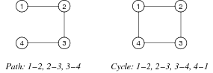

... Graph Terminology | 12/67
Connected graph
- there is a path from each vertex to every other vertex
- if a graph is not connected, it has ≥2 connected components
Complete graph K_{V}
- there is an edge from each vertex to every other vertex
- in a complete graph, E = V(V-1)/2
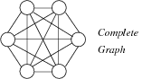

... Graph Terminology | 13/67
Tree: connected (sub)graph with no cycles
Spanning tree: tree containing all vertices
Clique: complete subgraph
Consider the following single graph:
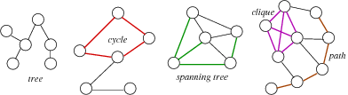
This graph has 25 vertices, 32 edges, and 4 connected components
Note: The entire graph has no spanning tree; what is shown in green is a spanning tree of the third connected component

... Graph Terminology | 14/67
A spanning tree of connected graph G = (V,E)
- is a subgraph of G containing all of V
- and is a single tree (connected, no cycles)
A spanning forest of non-connected graph G = (V,E)
- is a subgraph of G containing all of V
- and is a set of trees (not connected, no cycles),
  - with one tree for each connected component

Exercise #2: Graph Terminology | 15/67


- How many edges to remove to obtain a spanning tree?
- How many different spanning trees?

- 2
- 5⋅42-2=8 spanning trees (no spanning tree if we remove {e1,e2} or {e3,e4})

... Graph Terminology | 17/67
Undirected graph
- edge(u,v) = edge(v,u), no self-loops (i.e. no edge(v,v))
Directed graph
- edge(u,v) ≠ edge(v,u), can have self-loops (i.e. edge(v,v))
Examples:
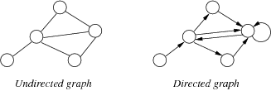

... Graph Terminology | 18/67
Other types of graphs …
Weighted graph
- each edge has an associated value (weight)
- e.g. road map (weights on edges are distances between cities)
Multi-graph
- allow multiple edges between two vertices
- e.g. function call graph (f() calls g() in several places)

Graph Data Structures

Graph Representations | 20/67
Defining graphs:
- need some way of identifying vertices
- could give diagram showing edges and vertices
- could give a list of edges
E.g. four representations of the same graph:
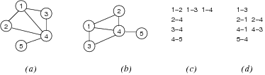

... Graph Representations | 21/67
We will discuss three different graph data structures:
- Array of edges
- Adjacency matrix
- Adjacency list

Array-of-edges Representation | 22/67
Edges are represented as an array of Edge values (= pairs of vertices)
- space efficient representation
- adding and deleting edges is slightly complex
- undirected: order of vertices in an Edge doesn't matter
- directed: order of vertices in an Edge encodes direction
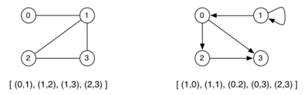
For simplicity, we always assume vertices to be numbered 0..V-1

... Array-of-edges Representation | 23/67
Graph initialisation
newGraph(V):
| Input number of nodes V
| Output new empty graph
|
| g.nV = V
| g.nE = 0
| allocate enough memory for g.edges[]
| return g

... Array-of-edges Representation | 24/67
Edge insertion
insertEdge(g,(v,w)):
| Input graph g, edge (v,w)
|
| i=0
| while i<g.nE ∧ (v,w)≠g.edges[i] do
| i=i+1
| end while
| if i=g.nE then
| g.edges[i]=(v,w)
| g.nE=g.nE+1
| end if

... Array-of-edges Representation | 25/67
Edge removal
removeEdge(g,(v,w)):
| Input graph g, edge (v,w)
|
| i=0
| while i<g.nE ∧ (v,w)≠g.edges[i] do
| i=i+1
| end while
| if i<g.nE then
| g.edges[i]=g.edges[g.nE-1]
| g.nE=g.nE-1
| end if

Cost Analysis | 26/67
Storage cost: O(E)
Cost of operations:
- initialisation: O(1)
- insert edge: O(E) (assuming edge array has space)
- delete edge: O(E) (need to find edge in edge array)
If array is full on insert
- allocate space for a bigger array, copy edges across ⇒ still O(E)
If we maintain edges in order
- use binary search to find edge ⇒ O(log E)

Exercise #3: Array-of-edges Representation | 27/67
Assuming an array-of-edges representation …
Write an algorithm to output all edges of the graph

show(g):
| Input graph g
|
| for all i=0 to g.nE-1 do
| print g.edges[i]
| end for

Adjacency Matrix Representation | 29/67
Edges represented by a V × V matrix
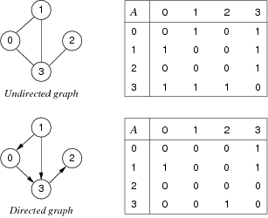

... Adjacency Matrix Representation | 30/67
Advantages
- easily implemented as 2-dimensional array
- can represent graphs, digraphs and weighted graphs
  - graphs: symmetric boolean matrix
  - digraphs: non-symmetric boolean matrix
  - weighted: non-symmetric matrix of weight values
Disadvantages:
- if few edges (sparse) ⇒ memory-inefficient

... Adjacency Matrix Representation | 31/67
Graph initialisation
newGraph(V):
| Input number of nodes V
| Output new empty graph
|
| g.nV = V
| g.nE = 0
| allocate memory for g.edges[][]
| for all i,j=0..V-1 do
| g.edges[i][j]=0
| end for
| return g

... Adjacency Matrix Representation | 32/67
Edge insertion
insertEdge(g,(v,w)):
| Input graph g, edge (v,w)
|
| if g.edges[v][w]=0 then
| g.edges[v][w]=1
| g.edges[w][v]=1
| g.nE=g.nE+1
| end if

... Adjacency Matrix Representation | 33/67
Edge removal
removeEdge(g,(v,w)):
| Input graph g, edge (v,w)
|
| if g.edges[v][w]≠0 then
| g.edges[v][w]=0
| g.edges[w][v]=0
| g.nE=g.nE-1
| end if

Exercise #4: Show Graph | 34/67
Assuming an adjacency matrix representation …
Write an algorithm to output all edges of the graph (no duplicates!)

... Adjacency Matrix Representation | 35/67
show(g):
| Input graph g
|
| for all i=0 to g.nV-1 do
| | for all j=i+1 to g.nV-1 do
| | if g.edges[i][j]≠0 then
| | print i"—"j
| | end if
| | end for
| end for

Exercise #5: | 36/67
Analyse storage cost and time complexity of adjacency matrix representation

Storage cost: O(V²)
If the graph is sparse, most storage is wasted.
Cost of operations:
- initialisation: O(V²) (initialise V×V matrix)
- insert edge: O(1) (set two cells in matrix)
- delete edge: O(1) (unset two cells in matrix)

... Adjacency Matrix Representation | 38/67
A storage optimisation: store only top-right part of matrix.
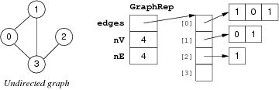
New storage cost: V-1 int ptrs + V(V+1)/2 ints (but still O(V²))
Requires us to always use edges (v,w) such that v < w.

Adjacency List Representation | 39/67
For each vertex, store linked list of adjacent vertices:
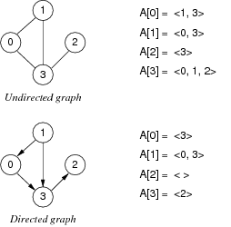

... Adjacency List Representation | 40/67
Advantages
- relatively easy to implement in languages like C
- can represent graphs and digraphs
- memory efficient if E:V relatively small
Disadvantages:
- one graph has many possible representations
(unless lists are ordered by same criterion e.g. ascending)

... Adjacency List Representation | 41/67
Graph initialisation
newGraph(V):
| Input number of nodes V
| Output new empty graph
|
| g.nV = V
| g.nE = 0
| allocate memory for g.edges[]
| for all i=0..V-1 do
| g.edges[i]=NULL
| end for
| return g

... Adjacency List Representation | 42/67
Edge insertion:
insertEdge(g,(v,w)):
| Input graph g, edge (v,w)
|
| if inLL(g.edges[v],w) then
| insertLL(g.edges[v],w)
| insertLL(g.edges[w],v)
| g.nE=g.nE+1
| end if

... Adjacency List Representation | 43/67
Edge removal:
removeEdge(g,(v,w)):
| Input graph g, edge (v,w)
|
| if inLL(g.edges[v],w) then
| deleteLL(g.edges[v],w)
| deleteLL(g.edges[w],v)
| g.nE=g.nE-1
| end if

Exercise #6: | 44/67
Analyse storage cost and time complexity of adjacency list representation

Storage cost: O(E)
Cost of operations:
- initialisation: O(V) (initialise V lists)
- insert edge: O(1) (insert one vertex into list)
- delete edge: O(E) (need to find vertex in list)
If vertex lists are sorted
- insert requires search of list ⇒ O(E)
- delete always requires a search, regardless of list order

Comparison of Graph Representations | 46/67

 | array  of edges | adjacency  matrix | adjacency  list
space usage | E | V² | V+E
initialise | 1 | V² | V
insert edge | E | 1 | 1
remove edge | E | 1 | E
Other operations:
 | array  of edges | adjacency  matrix | adjacency  list
disconnected(v)? | E | V | 1
isPath(x,y)? | E·log V | V² | V+E
copy graph | E | V² | V+E
destroy graph | 1 | V | V+E

Graph Abstract Data Type

Graph ADT | 48/67
Data:
- set of edges, set of vertices
Operations:
- building: create graph, add edge
- deleting: remove edge, drop whole graph
- scanning: check if graph contains a given edge
Things to note:
- set of vertices is fixed when graph initialised
- we treat vertices as ints, but could be arbitrary Items

... Graph ADT | 49/67
Graph ADT interface graph.h

typedef struct GraphRep *Graph;

typedef int Vertex;

typedef struct Edge { Vertex v; Vertex w; } Edge;

Graph newGraph(int V);
void insertEdge(Graph, Edge);
void removeEdge(Graph, Edge);
bool adjacent(Graph, Vertex, Vertex);

void freeGraph(Graph);

Graph ADT (Array of Edges) | 50/67
Implementation of GraphRep (array-of-edges representation)
typedef struct GraphRep {
Edge *edges;
int nV;
int nE;
int n;
} GraphRep;
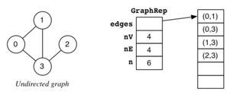

... Graph ADT (Array of Edges) | 51/67
Implementation of graph initialisation (array-of-edges representation)

Graph newGraph(int V) {
assert(V >= 0);
Graph g = malloc(sizeof(GraphRep)); assert(g != NULL);

g->nV = V; g->nE = 0;

g->n = Enough;
g->edges = malloc(g->n*sizeof(Edge)); assert(g->edges != NULL);

return g;
}
How much is enough? … No more than V(V-1)/2 … Much less in practice (sparse graph)

... Graph ADT (Array of Edges) | 52/67
Implementation of edge insertion/removal (array-of-edges representation)

bool eq(Edge e1, Edge e2) {
return ( (e1.v == e2.v && e1.w == e2.w)
|| (e1.v == e2.w && e1.w == e2.v) );
}

void insertEdge(Graph g, Edge e) {

assert(g != NULL && g->nE < g->n);
int i = 0;
while (i < g->nE && !eq(e,g->edges[i]))
i++;
if (i == g->nE)
g->edges[g->nE++] = e;
}

void removeEdge(Graph g, Edge e) {
assert(g != NULL);
int i = 0;
while (i < g->nE && !eq(e,g->edges[i]))
i++;
if (i < g->nE)
g->edges[i] = g->edges[--g->nE];
}

Exercise #7: Checking Neighbours (i) | 53/67
Assuming an array-of-edges representation …
Implement a function to check whether two vertices are directly connected by an edge
bool adjacent(Graph g, Vertex x, Vertex y) { … }

bool adjacent(Graph g, Vertex x, Vertex y) {
assert(g != NULL);
Edge e;
e.v = x; e.w = y;
int i = 0;
while (i < g->nE) {
if (eq(e,g->edges[i]))
return true;
i++;
}
return false;
}

Graph ADT (Adjacency Matrix) | 55/67
Implementation of GraphRep (adjacency-matrix representation)
typedef struct GraphRep {
int **edges;
int nV;
int nE;
} GraphRep;

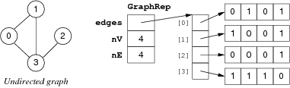

... Graph ADT (Adjacency Matrix) | 56/67
Implementation of graph initialisation (adjacency-matrix representation)

Graph newGraph(int V) {
assert(V >= 0);
int i;

Graph g = malloc(sizeof(GraphRep)); assert(g != NULL);
g->nV = V; g->nE = 0;

g->edges = malloc(V * sizeof(int *)); assert(g->edges != NULL);

for (i = 0; i < V; i++) {
g->edges[i] = calloc(V, sizeof(int)); assert(g->edges[i] != NULL);
}
return g;
}
standard library function calloc(size_t nelems, size_t nbytes)
- allocates a memory block of size nelems*nbytes
- and sets all bytes in that block to zero

... Graph ADT (Adjacency Matrix) | 57/67
Implementation of edge insertion/removal (adjacency-matrix representation)

bool validV(Graph g, Vertex v) {
return (g != NULL && v >= 0 && v < g->nV);
}

void insertEdge(Graph g, Edge e) {
assert(g != NULL && validV(g,e.v) && validV(g,e.w));

if (!g->edges[e.v][e.w]) {
g->edges[e.v][e.w] = 1;
g->edges[e.w][e.v] = 1;
g->nE++;
}
}

void removeEdge(Graph g, Edge e) {
assert(g != NULL && validV(g,e.v) && validV(g,e.w));

if (g->edges[e.v][e.w]) {
g->edges[e.v][e.w] = 0;
g->edges[e.w][e.v] = 0;
g->nE--;
}
}

Exercise #8: Checking Neighbours (ii) | 58/67
Assuming an adjacency-matrix representation …
Implement a function to check whether two vertices are directly connected by an edge
bool adjacent(Graph g, Vertex x, Vertex y) { … }

bool adjacent(Graph g, Vertex x, Vertex y) {
assert(g != NULL && validV(g,x) && validV(g,y));

return (g->edges[x][y] != 0);
}

Graph ADT (Adjacency List) | 60/67
Implementation of GraphRep (adjacency-list representation)
typedef struct GraphRep {
Node **edges;
int nV;
int nE;
} GraphRep;

typedef struct Node {
Vertex v;
struct Node *next;
} Node;

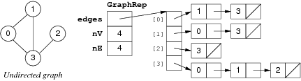

... Graph ADT (Adjacency List) | 61/67
Implementation of graph initialisation (adjacency-list representation)

Graph newGraph(int V) {
assert(V >= 0);
int i;

Graph g = malloc(sizeof(GraphRep)); assert(g != NULL);
g->nV = V; g->nE = 0;

g->edges = malloc(V * sizeof(Node *)); assert(g->edges != NULL);
for (i = 0; i < V; i++)
g->edges[i] = NULL;

return g;
}

... Graph ADT (Adjacency List) | 62/67
Implementation of edge insertion/removal (adjacency-list representation)

void insertEdge(Graph g, Edge e) {
assert(g != NULL && validV(g,e.v) && validV(g,e.w));

if (!inLL(g->edges[e.v], e.w)) {
g->edges[e.v] = insertLL(g->edges[e.v], e.w);
g->edges[e.w] = insertLL(g->edges[e.w], e.v);
g->nE++;
}
}

void removeEdge(Graph g, Edge e) {
assert(g != NULL && validV(g,e.v) && validV(g,e.w));

if (inLL(g->edges[e.v], e.w)) {
g->edges[e.v] = deleteLL(g->edges[e.v], e.w);
g->edges[e.w] = deleteLL(g->edges[e.w], e.v);
g->nE--;
}
}
inLL, insertLL, deleteLL are standard linked list operations (as discussed in week 3)

Exercise #9: Checking Neighbours (iii) | 63/67
Assuming an adjancency list representation …
Implement a function to check whether two vertices are directly connected by an edge
bool adjacent(Graph g, Vertex x, Vertex y) { … }

bool adjacent(Graph g, Vertex x, Vertex y) {
assert(g != NULL && validV(g,x));

return inLL(g->edges[x], y);
}

Exercise #10: Graph ADT Client | 65/67
Write a program that uses the graph ADT to
- build the graph depicted below
- print all the nodes that are incident to vertex 1 in ascending order
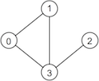

#include <stdio.h>
#include "Graph.h"

#define NODES 4
#define NODE_OF_INTEREST 1

int main(void) {
Graph g = newGraph(NODES);

Edge e;
e.v = 0; e.w = 1; insertEdge(g,e);
e.v = 0; e.w = 3; insertEdge(g,e);
e.v = 1; e.w = 3; insertEdge(g,e);
e.v = 3; e.w = 2; insertEdge(g,e);

int v;
for (v = 0; v < NODES; v++) {
if (adjacent(g, v, NODE_OF_INTEREST))
printf("%d\n", v);
}

freeGraph(g);
return 0;
}

Summary | 67/67
- Graph terminology
  - vertices, edges, vertex degree, connected graph, tree
  - path, cycle, clique, spanning tree, spanning forest
- Graph representations
  - array of edges
  - adjacency matrix
  - adjacency lists

- Suggested reading:
  - Sedgewick, Ch.17.1-17.5

Produced: 29 Aug 2017

